**CHAPTER: 1**

**INTRODUCTION**

**1. INTRODUCTION**

With global mobile phone subscribers estimated to 6.5 billion by 2016, the mobile phone is by far the most adopted consumer electronic in the world. As their processing power increases, the ability to leverage their mobility and computing power to solve daily problems increases. Hence, applications that have been traditionally confined to desktop computing are steadily being adapted for mobile phones. One of these applications is that of monitoring and tracking. While desktop computing still offers more processing power, the mobile phone has the advantage of constant reach ability and mobility that desktop computing lacks with comparable rich user experience.

The Android application gives the opportunity to share location information with the users through SMS. In order to do that, the application receives each SMS, matches contents of SMS with predefined attention word. If attention word matches with the predefined word than application makes device to get the location details of asset and acknowledges the user through SMS.

**1.1 EXISTING SOLUTIONS:**

The present solution involves a tracking unit, a SIM- based gateway and software that runs on a Laptop or Desktop PC. The gateway hardware is always connected to the laptop or PC, so when a location update is requested, the tracker sends the location to the gateway via SMS and the desktop application then reads the data off the gateway . Fig: 1.1 depicts the connection between the hardware in the existing system.

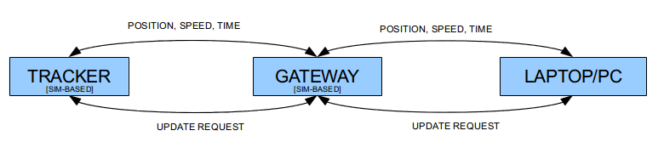

Fig: 1.1 Existing System

**PHONE TRACKING USING IMEI NUMBER:**

Every phone comes with a unique International Mobile Equipment Identify Number which can come in useful to track it in case of loss or theft. This number can be accessed by dialing *#06# and it is advisable to make a note of it as soon as you purchase your handset. In case the phone gets stolen, file an FIR with the police and give them its identity number.

Pass on a copy of the FIR and IMEI number to your service provider who will then be able to track your handset. With its IMEI number, a device can be traced even if it is being used with another SIM or even if it is switched off. Once the handset is located, request your service provider to block it from being used till you are able to get your hands on it again.

**1.2 PROPOSED SYSTEM:**

This project eliminates the need for the gateway hardware, thus cutting cost in two folds. First, we have the fact that the cost of the gateway hardware is totally eradicated. Secondly, the maintenance cost of this SIM-based hardware is also eliminated as this project allows users to leverage an existing SIM-based hardware, the mobile phone. This project therefore cuts down on initial price, maintenance cost and increases customer satisfaction by making the application more reachable for users. Fig: 1.2 illustrates the proposed system.

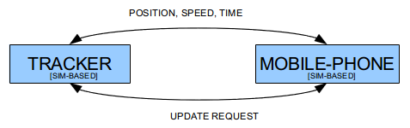

Fig: 1.2 Proposed System

Also worth noting is that this solution is server-less and does not require a monthly fee. While other tracking solution vendor exists such as VisiRun, TrackPeers and BizSpeed and others, none of them offers this option. This is particularly of major concern to companies and individuals who do not want their location information to be held by a third-party. At the time of writing, we are unaware of any Android SMS-based Asset Tracking application.

**1.3 SCOPE:**

This project supports the Android OS platform only and makes communication with the tracker through SMS messages only. The architecture, security and accuracy of the tracking unit itself are beyond the scope of this project.

**CHAPTER: 2**

**MOBILE PHONE APPLICATION DEVELOPMENT**

**2. MOBLIE PHONE APPLICATION DEVELOPMENT**

Mobile phone application development comes with its own unique set of challenges. While advancements have been made in processing power, touch interface and internet connectivity; battery longevity is still a major drawback. Therefore, application developers must find a way to conserve power as much as possible when using battery-draining resources such as the GPS receiver. Responsiveness is also a paramount factor in a mobile phone application, a 100 to 200 milliseconds delay is noticeable by a user, and therefore the application must always find a way of engaging the user while doing resource intensive work. Also, due to the small screen size of mobile phones, mobile phone developers must find creative ways to provide easy navigations from one functionality to another.

Mobile phone development also lacks cross-platform tools like those that can be found in desktop software development in which a developer can write the source code once and run it on different operating system. Due to lack of such tool, time and other resource constraints, one of the mobile platforms has to be chosen for this project.

**2.1 WHY ANDROID?**

Android is a software stack for mobile devices that includes an operating system, middle-ware and key applications. Android includes the application framework, the virtual machine, media support, integrated browser and optimized graphics support. It also includes support for GPS, Blue-tooth, Accelerometer, Camera, WIFI and 3G Networks amidst other things. Fig: 2.1 below shows the major components of the Android operating system. This project directly makes use of the Applications and the Application-framework layer and also makes use of the SQLite library.

Android will ship with a set of core applications including an email client, SMS program, calendar, maps, browser, contacts, and others. All applications are written using the Java programming language.

**2.1.1 ANDROID ARCHITECTURE:**

The following diagram shows the major components of the Android operating system. Each section is described in more detail below.

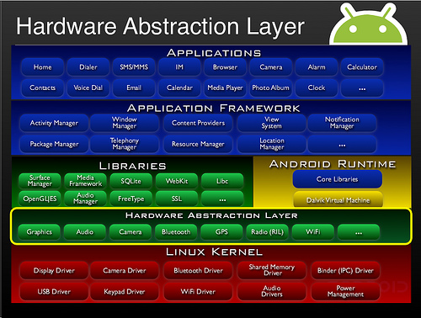

Fig: 2.1 Android Architecture

Presently, the dominant mobile phones Operating System are Apples' iOS, Google's Android, Nokia's Symbian, BlackBerry's OS and Microsoft's Windows Mobile. The criteria considered for choosing are, the market share, tablet support, the ease of application development, supported desktop platform and the license of the application. Table: 2.1 compares these operating systems according to the license, programming language and the officially supported development platform.

|  |  |  |  |
| --- | --- | --- | --- |
|  | License | Programming Language | Development  Os Platform |
| Android | Open  Source | MainlyJava | Cross Platform |
| iOS | Proprietary | Objective-C | Mac Only |
| Windows  Mobile | Proprietary | DotNETlanguages  ( C#, C++,VB. Net) | Windows Only |
| Blackberry  Os | Proprietary | Java | Windows |
| Symbian | Proprietary | C++ | Cross Platform |

Table: 2.1 Mobile OS Comparison

Android was preferred because of its open source nature, ease of development, zero barrier to entry and pervasiveness. “It quickly gained attractions by developers because of its fully developed features to exploit the cloud-computing model offered by web resources and it also enhances that experience with local data stores on the handset itself”. Presently, it is the market leader in smart phone. Application written for the handset can also be easily deployed for tablet devices with little or no technical changes needed.

Android is released under two different open source licenses. The Linux kernel which it is based upon, is released under the GNU Public License (GPL) as is required for anyone licensing the Linux operating system kernel. The Android platform, excluding the kernel, is licensed under the Apache Software License (ASL).

**2.1.2 APPLICATION FRAMEWORK:**

By providing an open development platform, Android offers developers the ability to build extremely rich and innovative applications. Developers are free to take advantage of the device hardware, access location information, run background services, set alarms, add notifications to the status bar, and much, much more.

Developers have full access to the same framework APIs used by the core applications. The application architecture is designed to simplify the reuse of components; any application can publish its capabilities and any other application may then make use of those capabilities (subject to security constraints enforced by the framework). This same mechanism allows components to be replaced by the user.

Underlying all applications is a set of services and systems, including:

• A rich and extensible set of Views that can be used to build an application, including lists, grids, text boxes, buttons, and even an embeddable web browser.

• Content Providers that enable applications to access data from other applications

(Such as Contacts), or to share their own data.

• A Resource Manager, providing access to non-code resources such as localized

Strings, graphics, and layout files.

• A Notification Manager that enables all applications to display custom alerts in the status bar.

• An Activity Manager that manages the lifecycle of applications and provides a common navigation backtracks.

**2.1.3 LIBRARIES:**

Android includes a set of C/C++ libraries used by various components of the Android system. These capabilities are exposed to developers through the Android application framework. Some of the core libraries are listed below:

**SYSTEM C LIBRARY**– A BSD-derived implementation of the standard C system library (lab), tuned for embedded Linux-based devices

**MEDIA LIBRARIES**- Based on PacketVideo'sOpenCORE; the libraries support playback and recording of many popular audio and video formats, as well as static image files, including MPEG4, H.264, MP3, AAC, AMR, JPG, and PNG

**SURFACE MANAGER**- Manages access to the display subsystem and seamlessly composites 2D and 3D graphic layers from multiple applications

**LIBWEBCORE**– A modern web browser engine which powers both the Android browser and an embeddable web view

**SGL**- the underlying 2D graphics engine

**3D LIBRARIES**- An implementation based on OpenGL ES 1.0 APIs; the libraries use either hardware 3D acceleration (where available) or the included, highly optimized 3D software rasterizer

**FREE TYPE**- bitmap and vector font rendering

**SQLITE**- a powerful and lightweight relational database engine available to all applications

**2.1.5 ANDROID RUNTIME:**

Android includes a set of core libraries that provides most of the functionality available in the core libraries of the Java programming language.

Every Android application runs in its own process, with its own instance of the virtual machine. Dali has been written so that a device can run multiple VMs efficiently. The Dali VM executes files in the Dali Executable (.decks) format which is optimized for minimal memory footprint. The VM is register-based, and runs classes compiled by a Java language compiler that have been transformed into the .decks format by the included "dx" tool.

The Dali VM relies on the Linux kernel for underlying functionality such as threading and low-level memory management.

**2.1.6 LINUX KERNEL:**

The basic layer is the Linux kernel. The whole Android OS is built on top of the Linux 2.6 Kernel with some further architectural changes made by Google.  It is this Linux that interacts with the hardware and contains all the essential hardware drivers. Drivers are programs that control and communicate with the hardware. For example, consider the Bluetooth function. All devices have a Bluetooth hardware in it. Therefore the kernel must include a Bluetooth driver to communicate with the Bluetooth hardware.  The Linux kernel also acts as an abstraction layer between the hardware and other software layers. Android uses the Linux for all its core functionality such as Memory management, process management, networking, security settings etc. As the Android is built on a most popular and proven foundation, it made the porting of Android to variety of hardware a relatively painless task.

**2.2 ANDROID DEVELOPMENT:**

What goes on in an Android application is mainly divided into two, including the visual part, which the user interacts with and the non-visual, which runs in the background. The visual part is termed an activity. An activity is usually a single screen that the user sees on the device at one time. An application typically has multiple activities, and the user flips back and forth among them. The previous activity maybe paused or destroyed and the new one maybe newly created or just resumed. Fig: 2.2 below show an activity life-cycle and the different states which it can exist in.

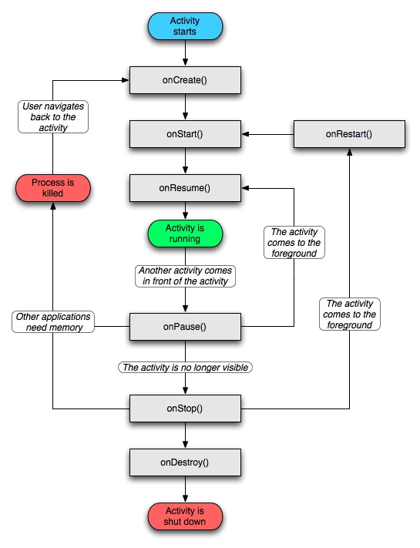

Fig: 2.2 Activity Life Cycle

The non-visual parts are called Services. They run in the background and don’t have any user interface components. They perform actions such as polling data from a server on the Internet, playing music in the background etc. They are responsible for those actions that must continue while the user flips between activities of the same or different applications.

BroadcastReceiver is also an important component of Android development. It is the system's way of alerting applications of certain events in the systems when they occur. For example, the system broadcasts an SMS arrival event when a new SMS arrives on the mobile phone. Subsequently all application that are registered to receive this events will be notified and each of them will respond accordingly.

**2.2.1 ANDROID SDK AND ECLIPSE:**

The Android SDK provides the tools and APIs necessary to begin developing applications on the Android platform using the Java programming language. The SDK is available on Windows, Linux and Mac.

Eclipse is a multi-platform development environment that runs on all major operating system. Android provides a plug-in for Eclipse that allows easy use and control of the Android SDK facilities. This plug-in is called ADT Plugin (Android Development Tool). Once installed the ADT plug-in is made to point to the SDK location thereupon most of the SDK tools can then be accessed through Eclipse. While other IDEs exist for Android development, Eclipse was preferred because it's the officially supported environment.

**2.2.2 ANDROID DEBUG BRIDGE:**

Android Debug Bridge (adb) is a versatile tool that allows managing the state of an emulator instance or an Android-powered device. It is part of the tool bundled with Android SDK. With it, one can issue commands to the emulator or device and inspect or modify its internal states. Table: 2.2 shows the adb commands that was commonly used during the development of this project.

|  |  |
| --- | --- |
| Command | Description |
| devices | Prints alistof allattached emulator/device instances |
| shell | Startsa remote shellin thetarget emulator/device instance. |
| logcat | Prints logdatato the screen. |
| push <local><remote> | Copiesa specifiedfilefromyour developmentcomputer toan emulator/device instance. |
| pull<remote><local> | Copiesa specifiedfilefroman emulator/device instance toyour developmentcomputer. |

Table: 2.2 Commonly used abd commands

Some of Linux command line functions are also accessible through the adb. First, the command adb shell has to be run to log in; afterwards, commands such as ps, ls and top can then be run. While the Eclipse plug-in provides a GUI front-end to most of the adb functionalities, the command line is well suited or sometimes necessary to access the device or emulator. Command-line invocation is also preferred, because sometimes the eclipse plug-in loses communication with the emulator server.

During the development of this project, the command-line has been mainly used in viewing the database, viewing the system logs and managing more than one emulator at a time. Viewing the database is done by evoking the sqlite3 command with the full path to the database location.

**CHAPTER: 3**

**SYSTEM SPECIFICATION**

**3. SYSTEMSPECIFICATION**

The hardware involved in the project includes the tracker and the mobile phone to which the application is installed. The tracker includes an SMS module and a GPS receiver. The tracker obtains the location, direction and speed information from the GPS receiver and sends it via SMS to a configured mobile phone number at preconfigured intervals or when certain events occur. The application receives and interprets the SMS, and shows the asset location on a map and performs other associated logic.

**3.1 SYSTEM REQUIREMENTS ELICITATION:**

System Planning is one of the important items to be considered before actually beginning the project. Planning is performed on the issued like defining Life Cycle Model and an organizational structure project, configuration management, quality and validation activities.

In the process of System Planning various phase-department tools, techniques and notations are determined. Preliminary cost estimates for the system development and preliminary development schedules are established. Preliminary estimates of the computing resources required to operate and maintain the system are developed, glossary of terms are prepared.

**3.1.1 SOFTWARE REQUIREMENTS:**

Operating system: Windows 7

Eclipse

Android SDK

Android ADT

**3.1.2 HARDWARE REQUIREMNETS:**

Processor : core2duo

Cache Memory : 1MB

HDD : 500 GB

RAM : 2 GB

Processor Speed : 2.16 GHz

Display Type : HD

**3.1.3 APPLICATION REQUIREMENTS:**

The application is targeted at any Android powered mobile device running at least Android 2.2, Froyo. It should be intuitive to use and be locale aware. Users would be offered feedback for important actions, to make them feel on track. Also when user error occurs, the user should get simple and easy to understand error message and what to do next. The device must be equipped with GPS location services, Data Connection and also with a privilege to send SMS through the network.

**3.1.4 NON FUNCTIONAL REQUIREMENTS:**

**PERFORMANCE REQUIREMENTS:**

Application must respond within 5 seconds excluding GPS enabling time. The user must use the required option to get the information of the users.

**RELIABILITY:**

This application has various other features like SMS this can be extensible with many features in the user devices.

**AVAILABILITY:**

This proposed system find extended application who are installed this application those users can be get the location of the device and send the details back to requesting phone

**MAINTAINABILITY:**

Since we are using eclipse environment and android SDK to support our application, maintenance is very easy and economical also.

**3.2 SYSTEM COMPONENTS OVERVIEW:**

**3.2.1 ASSET MANAGEMENT:**

An asset in the context of this project refers to a real world object to which the tracker is attached; for example, a vehicle or truck. The user should be able to register a new asset, edit and delete existing ones. Rules can be set to outline the fields that are to be provided when registering an asset. It also describes the type of data required for registration and from where the user will obtain them.

At each instance of the application an asset must be selected and monitored. The application should also allow user to select which asset is being actively monitored.

**3.2.2 LOCATION MANAGEMENT:**

At each instance of the application, the last known location of the selected asset must be visible on the map. The location of an asset, whether selected or not must always be updated whenever a message meant for it arrives. The user should also be able to view her location relative to the asset and the proximity of distance should be made known to the user. The markers used to show the asset's last location and those before it, should be different. Separate markers should also be used to show the user's location. One key feature needed is the ability to create a “geofence”, a circular boundary, as shown in Fig: 3.1 with a green circle. The asset is not expected to step out of this geofence, so when it is determined to be out of it, some form of notification should be used to alert the user of the violation. The notification alert can be by sound or vibration or both, based on user preference.

Initially the tracker is configured to send location data only on request, however it also has the ability to send data at some regular intervals or when certain events occur. User should have the ability to change this setting, and make the tracker send data at some intervals as described.

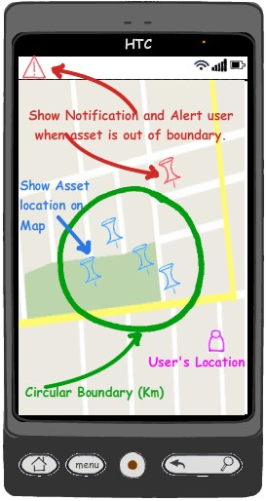

Fig: 3.1 Mockup of Application

**3.2.3 DATA MANAGEMENT:**

The users should also have complete control over the location data and should be given the option to delete the mall or with in some specified time range. It is desirable that the location data should be exportable to other format such as the GPX or KMLformat.

The tracker's password should not be visible or accessible to an external party. Some form of obfuscation or encryption should be provided such that if the user loses the phone, the trackers password is not easily obtainable from any of the data storing mechanism employed. At no point should any unrelated user specific data be stored or collected through the application to a web-server.

**3.2.4 TRACKER COMMUNICATION:**

Communication between the application and the tracker is done only through SMS messages. Since both the tracker and mobile phone are SIM based and battery-powered devices loss of battery and lack of SMS Gateway may cause them not to receive a message. As for the tracker when it regains connectivity or power, it processes the first SMS it receives and discards any new ones it receives while doing so. Therefore, the application should provide a way of ensuring its state and that of the tracker stays synchronized with regards to update interval described in Receiving Data. When the phone recovers from a loss of power or connectivity it should be able to cope with the high volume of messages it may subsequently receive.

From the tracker side, messages are only initiated when requested, or when demanded to be sent at some certain interval so are certain event as further explained.

**RECEIVING DATA:**

The message received from the tracker contains the GPS location information, speed and direction of the asset being tracked encoded in a modified NMEA RMC format. The RMC, Recommended Minimum Sentence C, is the NMEA version of essential GPS pvt (position, velocity, time) data. A complete data unit is referred to as a sentence. An NMEA sentence begins with a dollar sign and the letters GP, ($GP) and contains a number of fields, separated by commas. Each field in the sentence is important in determining the location, velocity, direction of the asset at a particular point in time except for the last field which is a checksum to ensure the data has not been tampered with. The fields and their description are shown in Table: 3.1. Using the following NMEA sentence as a guide, the table describes the fields and their interpretation.

Example : $ GPRMC,123519,A,4807.038,N,01131.000,E,022.4,084.4,230394,003.1,W*6A

|  |  |  |  |
| --- | --- | --- | --- |
| FIELD | DESCRIPTION | EXAMPLE | INTERPRETATION |
| SentenceType | Shows it is an RMC | RMC | Sentenceis RMC |
| Time | Six-digit letters describing thetimethe data was takenin UTC | 123519 | 12:35:19 UTC |
| Status | Thevaluecan either be  A(Active) orV(Void) | A | Good fix |
| Latitude | Latitude valuein degrees | 4807.038 | 48° 7' 38.000" |
| Latitude direction | Thedirection of latitude. Caneitherbe N or S  ( North or South) | N | North |
| Longitude | Longitudevalue in degrees | 01131.000 | 11° 31' 000" |
| Longitude direction | Thedirection of latitude. Caneitherbe EorW (EastorWest) | E | East |
| Speed | Speedover the ground in  Knots | 022.4 | 22.4 Knots |
| Trackangle | Trackanglein degrees | 084.4 | 84° 4' |
| Date | Datewhenthe data was taken in the format (ddmmyy) | 230313 | 23rd of March 2013 |
| MagneticVariation | MagneticVariation | 003.1 | 3° 1' |
| MagneticVariation  Direction | MagneticVariation  Direction | W | West |
| Checksum | Checksumto checkthe validityof the data. Startswith * | *6A | Checksumvalue |

Table: 3.1 NMEA Fields

The NMEA sentence was modified by replacing the first 6 characters i.e., “$GPRMC” to '%$' followed by the four letters that uniquely identifies the asset. Therefore for an asset with id, WXYZ, a sample message will be

%$WXYZ,123519,A,4807.038,N,01131.000,E,022.4,084.4,230394,003.1,W*6A.

**SENDING DATA:**

Messages sent to the tracker from the application are primarily to change how often or under what circumstances the tracker sends location updates. All messages sent should be made only with explicit consent of the user and the monetary consequence should be made known to the user.

Primarily, the tracker sends location data when it receives command requesting it to do so. However, it can also be configured either to work in a timing mode or in a tracking mode. In the timing mode, the tracker sends location information regardless of the state of the asset at specific time intervals. The interval between each location updates vary from ten minutes to five hours. In the tracking mode however, location updates are only sent when variables such as the speed and direction of the asset changes. Changing time interval in timing mode or turning off updates can be done by sending commands to the tracker.

**3.3 SYSTEM ARCHITECTURE:**

The system architecture mainly involves the basic components involved in the successful operation of the application. Fig: 3.2 explains the overview of the system and also the basic architecture of the system.

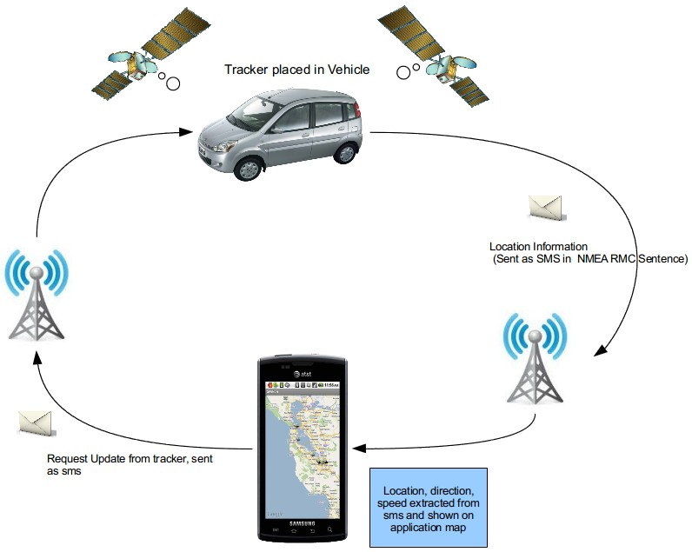

Fig: 3.2 System Architecture

**CHAPTER: 4**

**SYSTEM DESIGN**

**4. SYSTEM DESIGN**

System design phase follows system analysis phase. Design is maintaining record proof design divisions and providing a blueprint for the implementation phase. Design is the bridge between system analysis and system implementation. The design is a solution, a “how to” approach to the creation a new system.

**4.1 DESIGN OVERVIEW:**

Unified Modeling Language (UML) combines techniques from data modeling (entity relationship diagrams), business modeling (work flows), object modeling, and component modeling. It can be used with all processes, throughout the software development life cycle, and across different implementation technologies.

The Unified Modeling Language (UML) offers a standard way to visualize a system's architectural blueprints, including elements such as:

• Activities

• Actors

• Business processes

• Database schemas

• (logical) components

• Programming language statements

• Reusable software components.

UML has synthesized the notations of the Booch method, the Object-modeling technique (OMT) and Object-oriented software engineering (OOSE) by fusing them into a single, common and widely usable modeling language. UML aims to be a standard modeling language which can model concurrent and distributed systems.

UML models may be automatically transformed to other representations (e.g. Java) by means of QVT-like transformation languages. UML is extensible, with two mechanisms for customization: profiles and stereotypes.

**4.2 SYSTEM DESIGN MODEL:**

System design model is like a blue print for a building, it specifies all the features that are to be in the finished product. Design states how to accomplish objectives determined in the analysis phase.

**4.2.1 USECASE DIAGRAM:**

The Use Case model describes the proposed functionality of the new system. A Use Case represents a discrete unit of interaction between a user (human or machine) and the system.

A Use Case is a single unit of meaningful work; for example login to system, register with system and create order are all use cases. Each use case has a description which describes the functionality that will be built in the proposed system. A use case may ‘include’ another use case’s functionality or ‘extend’ another use case with its own behavior. Use cases are typically related to ‘actors’. An actor is a human or machine entity that interacts with the system to perform meaningful work.

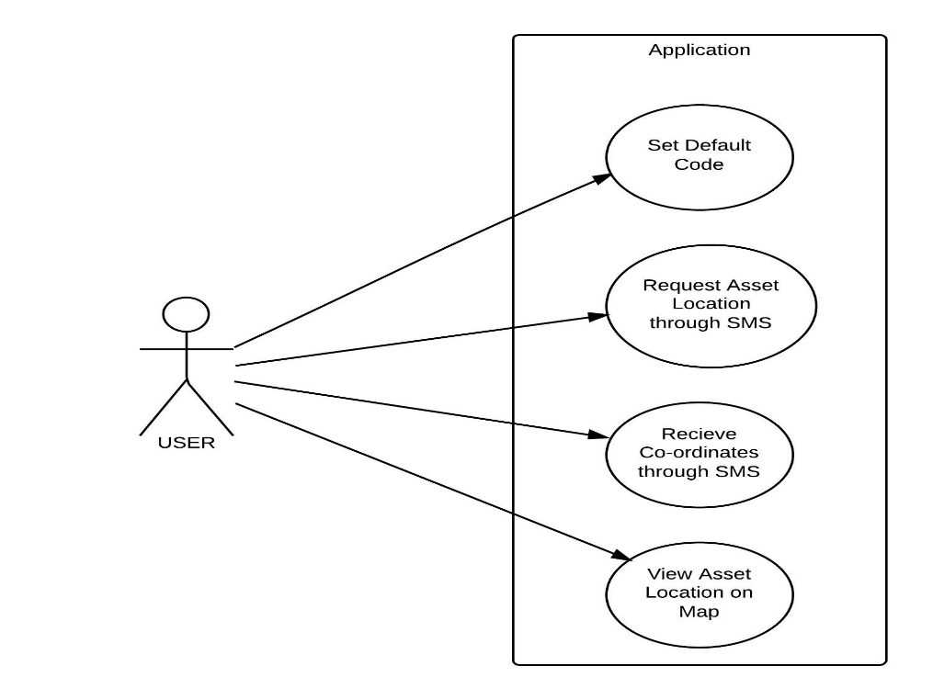

Fig: 4.1 Use-Case Diagram

**4.2.2 CLASS DIAGRAM:**

The UML class diagram also referred to as object modeling, is the main static analysis diagram. Object modeling is the process by which the logical objects in the problem space are represented by the actual objects in the program. These diagrams show a set of classes, interfaces, and collaborations and their relationships. These diagrams address the static design view of a system.

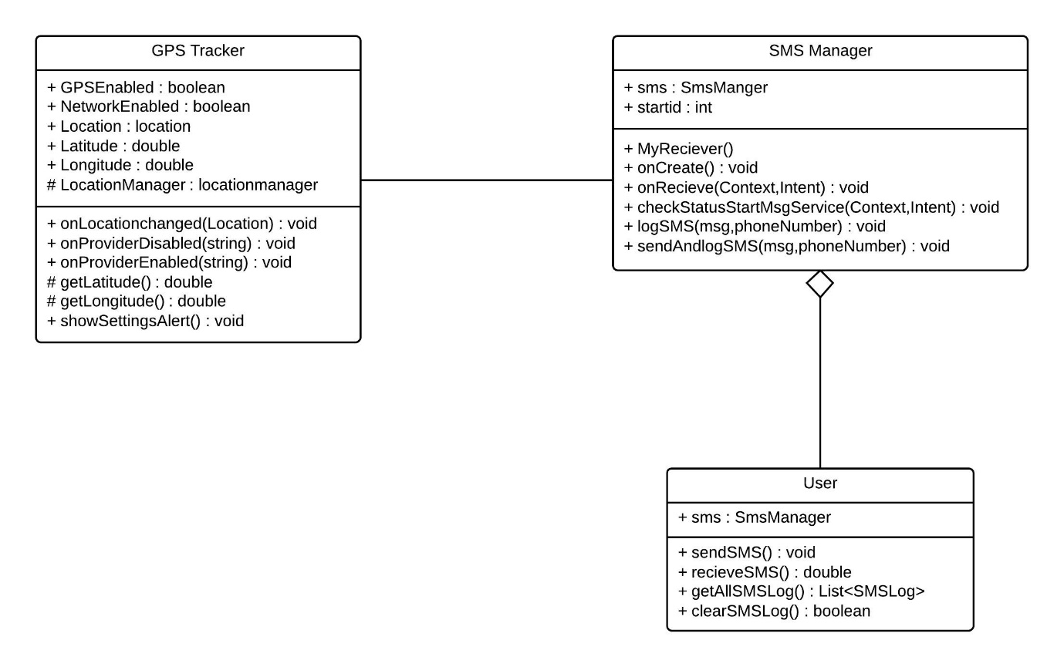

Fig: 4.2 Class Diagram

**4.2.3 SEQUENCE DIAGRAM:**

Sequence diagrams describe the behavior of a system by viewing the interaction between the system and its environment. It shows an interaction arranged in a time sequence. It shows the objects participating in interaction by their lifelines and the messages they exchange, arranged in a time sequence.

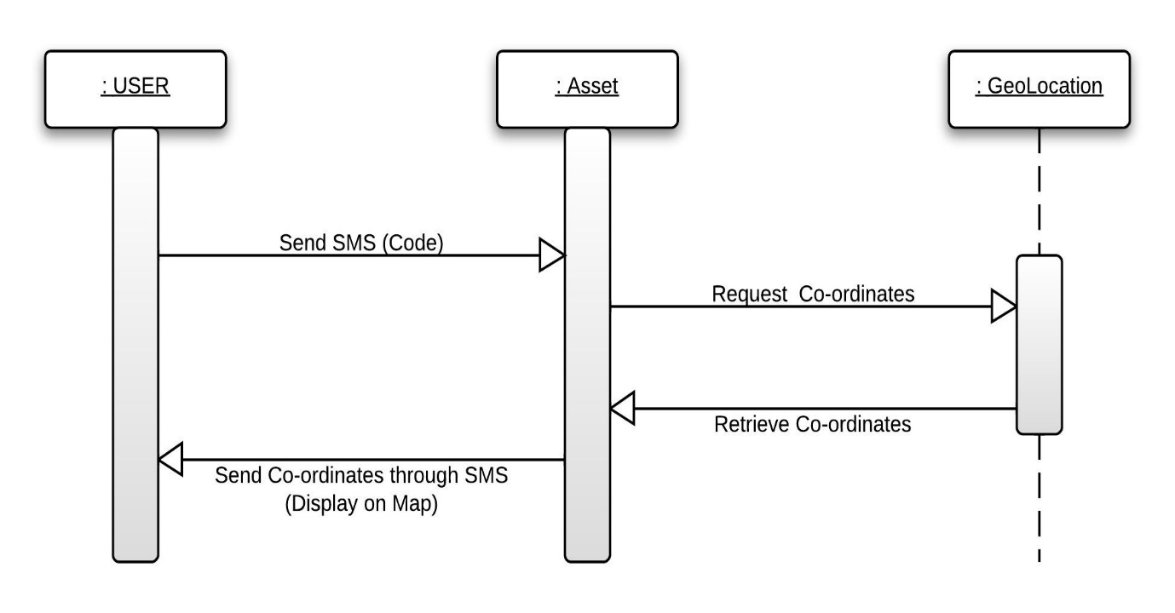

Fig: 4.3 Sequence Diagram

**4.2.4 COLLABORATION DIAGRAM:**

Collaboration diagrams show objects, their links and messages. Each collaboration diagram provides a view of the interactions or structural relationships that occur between objects and object-like entities in the current model.

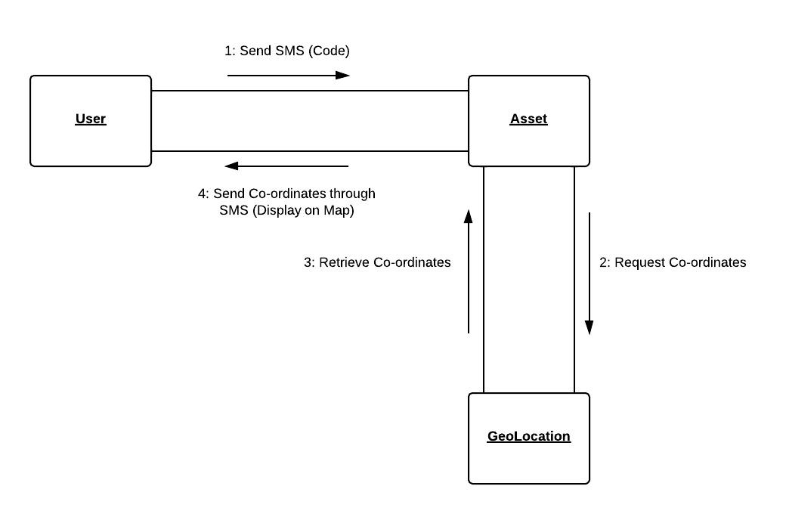Fig: 4.4 Collaboration Diagram

**4.2.5 ACTIVITY DIAGRAM:**

Activity diagram is a variation or special case of a state machine, in which the states are activities representing the performance of operations and the transitions are triggered by the completion of operations. Unlike state diagrams that focus on the events occurring to a single object as it responds to messages, an activity diagram can be used to model an entire business process. Activity diagrams are constructed from a limited number of shapes, connected with arrows. The most important shape types:

• Rounded rectangles represent actions;

• Diamond represents decisions;

• Bars represent the start (split) or end (join) of concurrent activities;

• A black circle represents the start (initial state) of the workflow;

• An encircled black circle represents the end (final state).

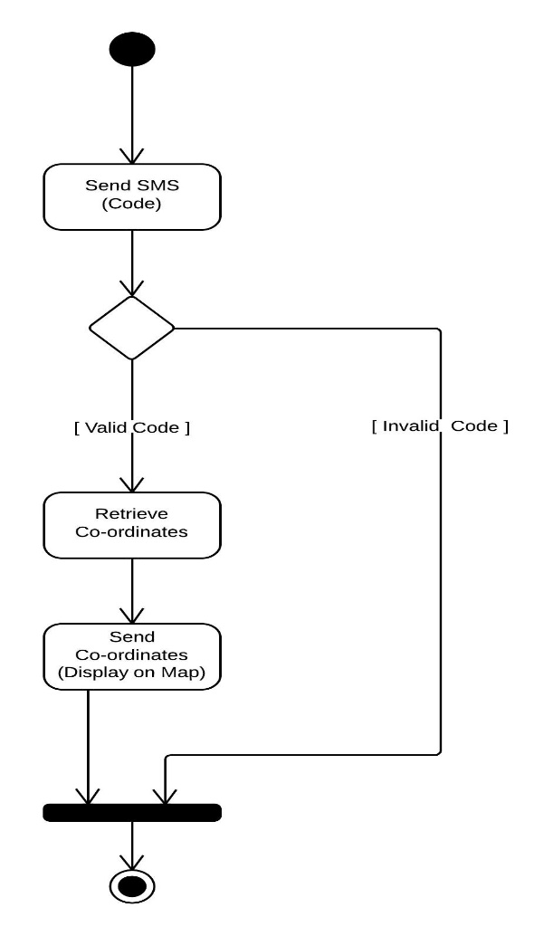

Fig: 4.5 Activity Diagram

**4.2.6 STATE CHART DIAGRAM:**

A State diagram is a graph whose nodes are states and whose directed arcs are transitions between the states. It specifies the state sequences caused by event sequences. State names must be unique within the scope of the diagram. State diagrams are used to give an abstract description of the behavior of a system. This behavior is analyzed and represented in series of events that could occur in one or more possible states.

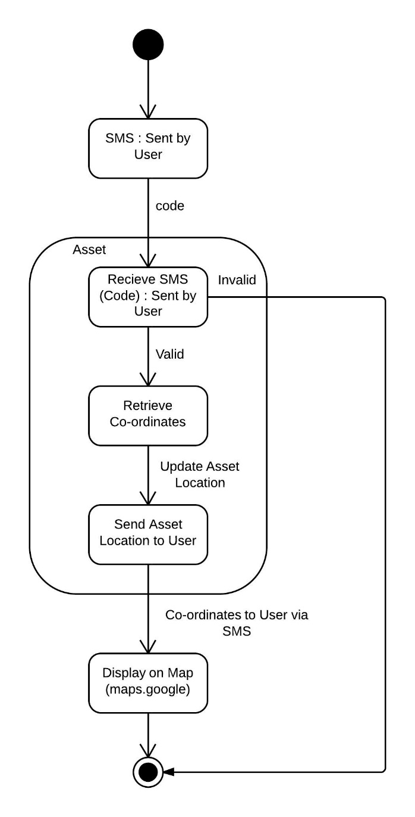

Fig: 4.6 State Chart Diagram

**4.2.7 DEPLOYMENT DIAGRAM:**

Deployment diagrams are used to visualize the topology of the physical components of a system where the software components are deployed. So deployment diagrams are used to describe the static deployment view of a system. Deployment diagrams consist of nodes and their relationships.

The purpose of deployment diagrams can be described as:

* Visualize hardware topology of a system.
* Describe the hardware components used to deploy software components.
* Describe runtime processing nodes.

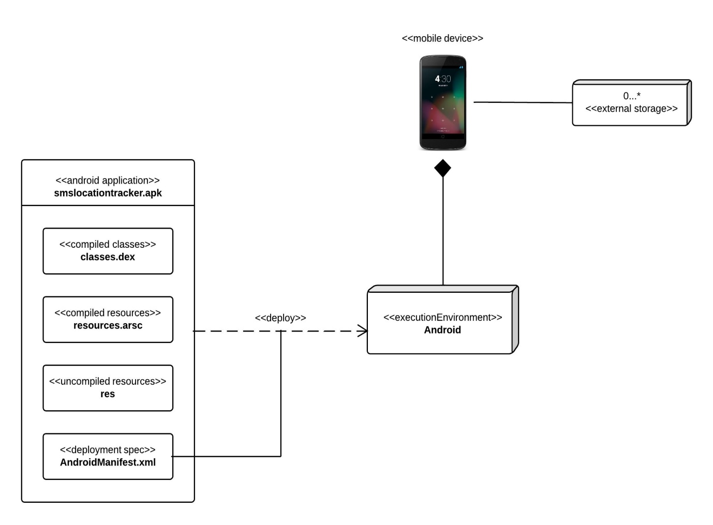

Fig: 4.7 Deployment Diagram

**CHAPTER: 5**

**SYSTEM IMPLEMENTATION**

**5. SYSTEM IMPLEMENTATION**

**5.1 SAMPLE CODE:**

public class Gps extends Activity implements LocationListener

{

privateLocationManagerlocationManager;

@Override

protected void onCreate(Bundle savedInstanceState)

{

super.onCreate(savedInstanceState);

setContentView(R.layout.activity_gps);

locationManager = (LocationManager) getSystemService(Context.LOCATION_SERVICE);

locationManager.requestLocationUpdates(LocationManager.GPS_PROVIDER,3000,10,this);

}

@Override

public void onLocationChanged(Location location)

{

String str = "Latitude: "+location.getLatitude()+"Longitude: "+location.getLongitude();

Toast.makeText(getBaseContext(), str, Toast.LENGTH_LONG).show();

}

@Override

public void onProviderDisabled(String provider)

{

Toast.makeText(getBaseContext(), "Gps turned off ", Toast.LENGTH_LONG).show();

}

@Override

public void onProviderEnabled(String provider)

{

Toast.makeText(getBaseContext(), "Gps turned on ", Toast.LENGTH_LONG).show();

}

}

**5.2 USER INTERFACE (SCREEN SHOTS):**

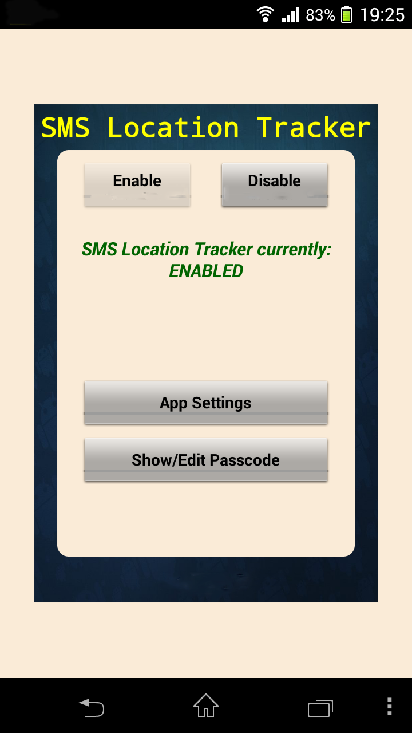

Fig: 5.1 Service Enabled

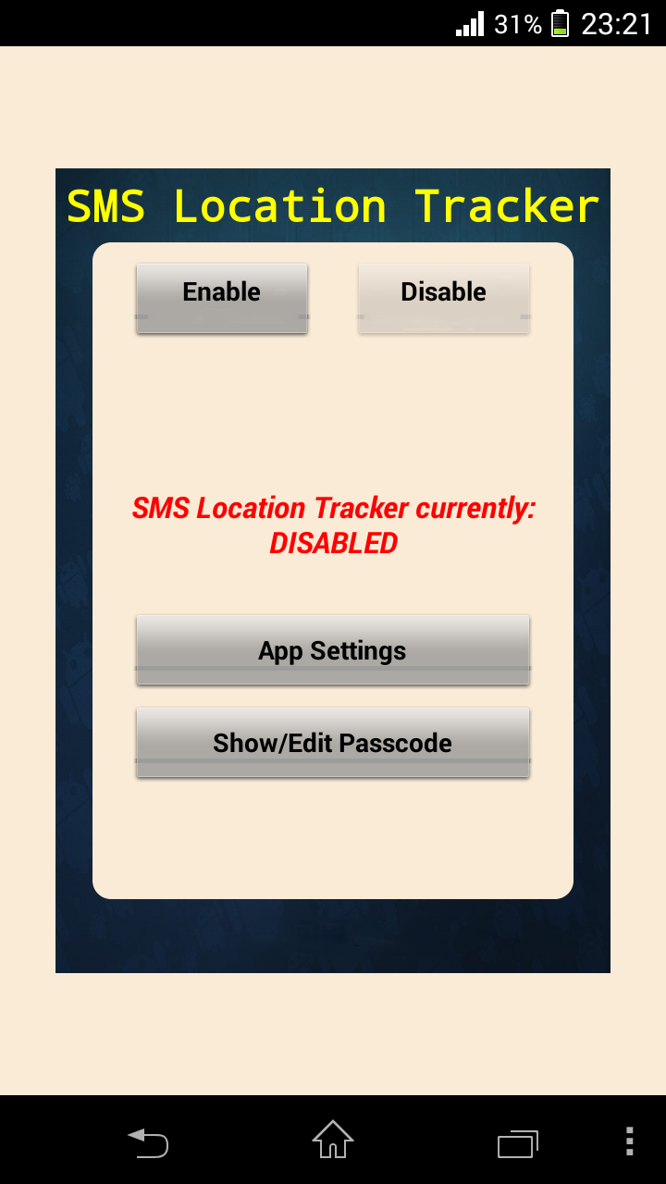

Fig: 5.2 Service Disabled

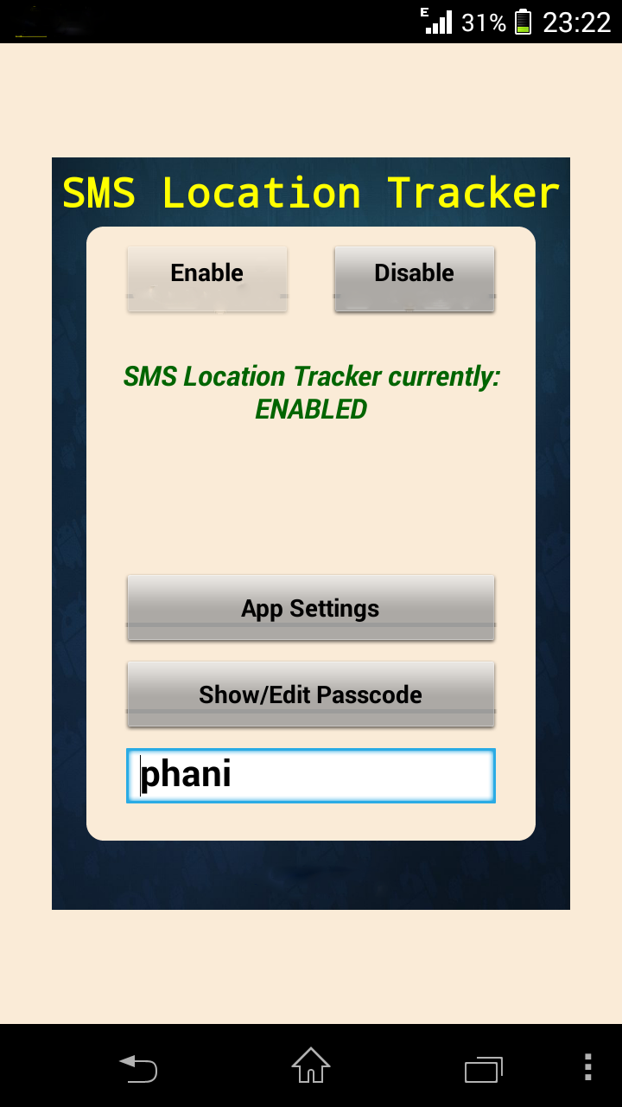

Fig: 5.3 Application Enabled with Passcode

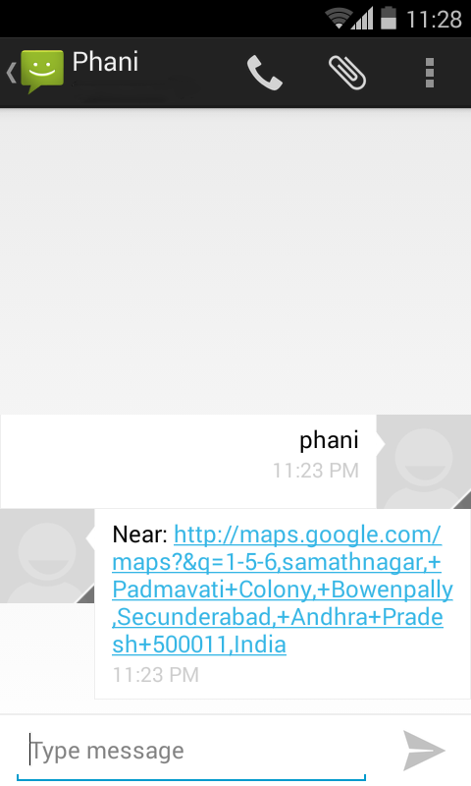

Fig: 5.4 SMS with Location Link of Asset Sent to User

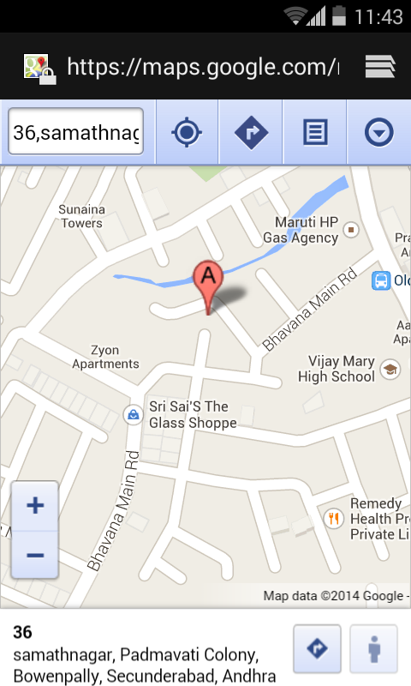

Fig: 5.5 Location of Asset

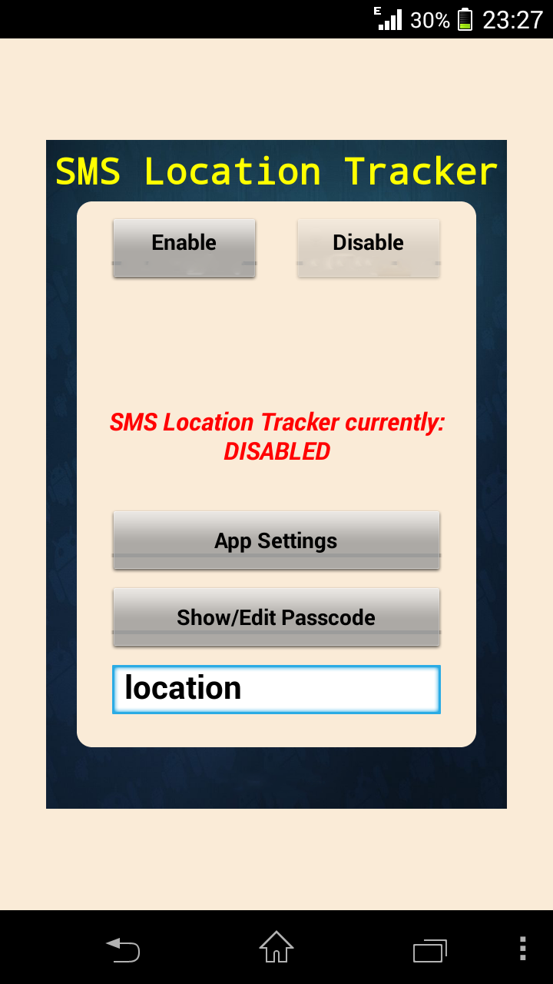

Fig: 5.6 Application Disabled

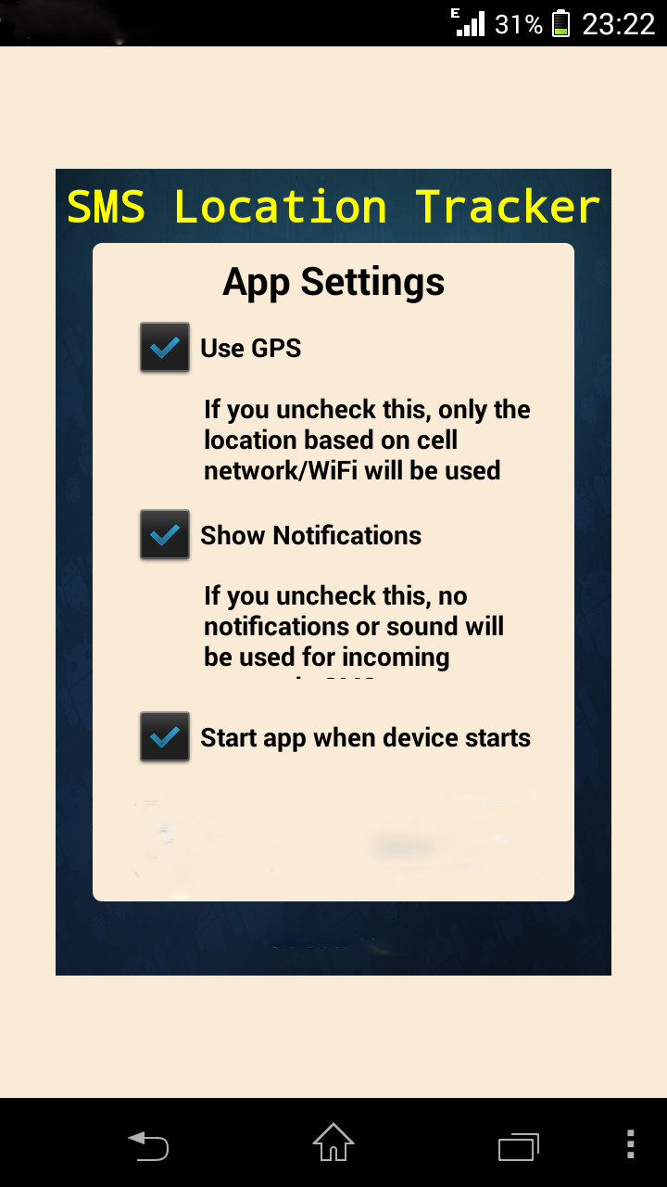

Fig: 5.7 App Settings Turned OFF

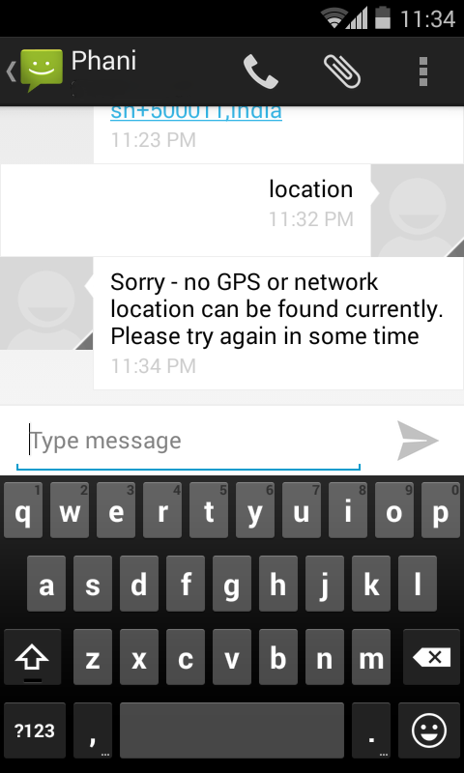

Fig: 5.8 Error SMS Sent to User

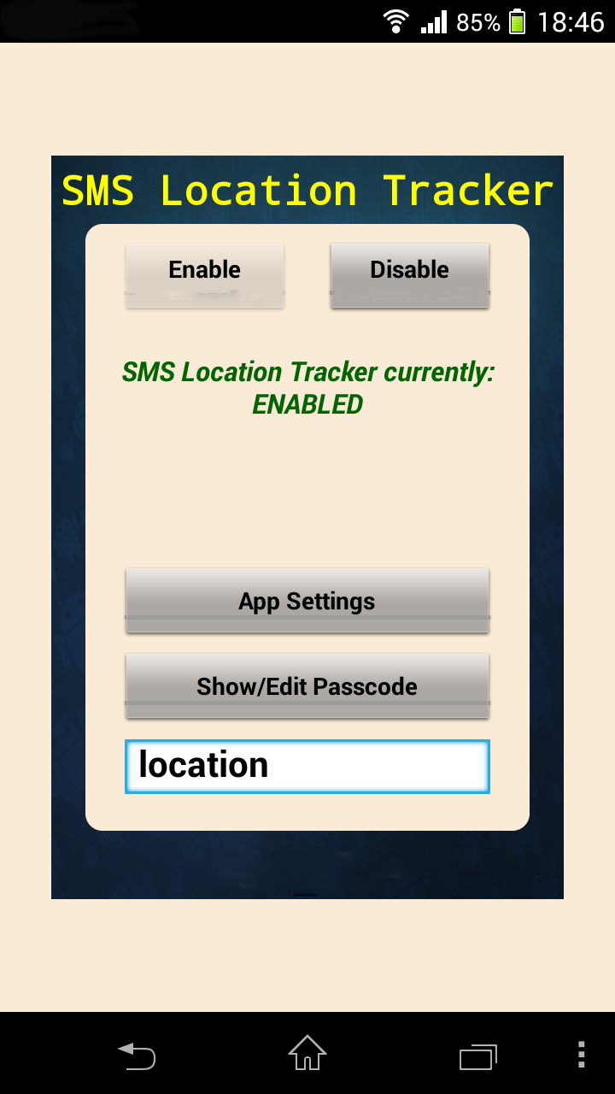

Fig: 5.9 Application Enabled with New Passcode

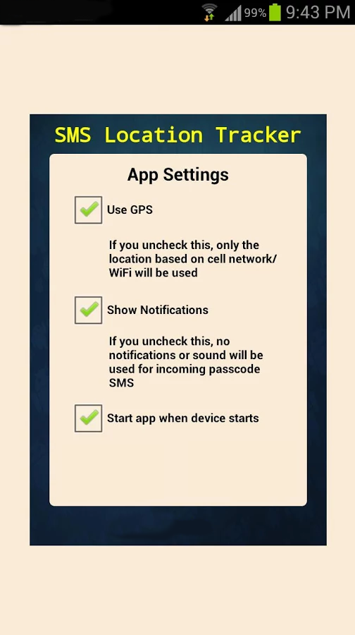

Fig: 5.10 App Settings Turned ON

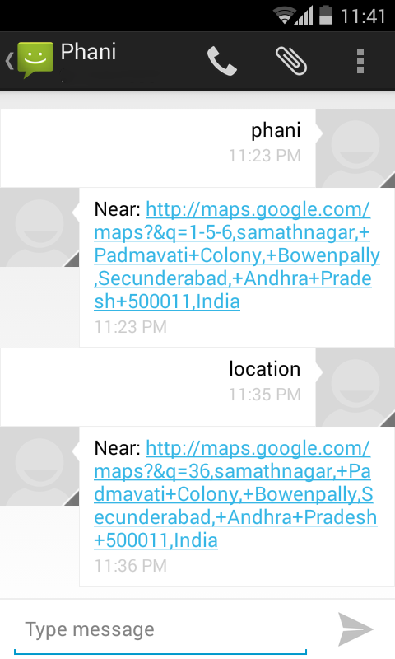

Fig: 5.11 New Location Link Sent to User



Fig: 5.12 Location of Asset on Google Maps

**CHAPTER: 6**

**TESTING**

**6. TESTING**

Software testing is a very broad area, which involves many other technical and non-technical areas, such as Specification, design and implementation, maintenance, process and management issues in software engineering. Software testing is an investigation conducted to provide stakeholders with information about the quality of the product or service under test.

Software testing can also provide an objective, independent view of the software to allow the business to appreciate and understand the risks of software implementation.

Software testing can be stated as the process of validating and verifying that a computer program/application/product:

• meets the requirements that guided its design and development,

• works as expected,

• can be implemented with the same characteristics,

• And satisfies the needs of stakeholders.

**TESTING SPECTRUM:**

Testing is involved in every stage of software life cycle, but the testing done at each level of software development is different in nature and has different objectives.

**SYSTEM TESTING:**

System testing tends to affirm the end-to-end quality of the entire system. System test is often based on the functional/requirement specification of the system. Non-functional quality attributes, such as reliability, security, and maintainability, are also checked.

**ACCEPTANCE TESTING:**

Acceptance testing is done when the completed system is handed over from the developers to the customers or users. The purpose of acceptance testing is rather to give confidence that the system is working than to find errors.

**6.1 UNIT TESTING:**

Unit testing is done at the lowest level. It tests the basic unit of software, which is the smallest testable piece of software, and is often called “unit”, “module”, or “component” interchangeably.

|  |  |  |  |  |
| --- | --- | --- | --- | --- |
| SIN | SCENARIOS | EXPECTED RESULT | ACTUAL RESULT | STATUS |
| 1 | Install SmsTracker.apk file on Android phone | Installation Successful | Installation Successful | Success |
| 2 | Check whether UI Is Displaying On screen | Display UI | Display UI | Success |
| 3 | Send SMS to Application | SMS Sent | SMS Sent | Success |
| 4 | Receive SMS Inside Application | SMS Received | SMS Received | Success |
| 5 | Read Contents Of SMS | Contents Read | Contents Read | Success |
| 6 | Retrieve Latitude And Longitude | Latitude And Longitude | Latitude And Longitude | Success |

Table: 6.1 Unit Testing

**6.2 INTEGRATION TESTING:**

Integration testing is performed when two or more tested units are combined into a larger structure. The test is often done on both the interfaces between the components and the larger structure being constructed, if its quality property cannot be assessed from its components.

1. Application starts on SMS receive.

2. Contents of SMS read and matches with the attention word.

3. Application retrieves the current location details and sends back to the user through a SMS.

4. Application Stops.

**6.3 JUNIT TESTING:**

JUnit is an API that enables developers to easily create Java test cases. It provides a comprehensive assertion facility to verify expected versus actual results. Android provides a testing framework which is based on JUnit that could be used to test every aspect of the application at every level. With the JUnit it is possible to programmatically input text into fields, make selections, click buttons and navigate the application, thereby making it possible to test the expected outcome of events. This was particularly useful in guaranteeing some of the applications logic still works when heavy changes were being made to the source code. We can also assert that the RegisterAssetActivity class sets an error message if the user does not select an asset type.

It was also used in testing the application reaction to changes in system configuration like screen orientation, lack of SMS, slow network connection etc.

**6.4 TRACKER COMMUNICATION TESTING:**

A separate Android application was written to simulate the functionalities of the tracker. This was written at first when the tracker was unavailable and subsequently used to avoid incurring too much cost of sending real SMS if the actual mobile phone and tracker is used. The simulation was possible due to the fact that Android provides the ability to have two emulator instances which can communicate with each other via SMS. Also latitude and longitude values could also be sent to an emulator to simulate its position. The simulator application was written such that it sends it location information at some intervals as the tracker would have done using the same NMEA format. Testing with the actual tracker was performed also to ensure that functionalities work as expected.

**CHAPTER: 7**

**CONCLUSION**

**7. CONCLUSION:**

“Location Tracking Using SMS“ project shows that smart phones such as Android, can be used as an additional device that can be used for GPS telemetry with SMS as the medium of data exchange.All the features work on SMS basis. Therefore, incoming SMS format plays a vital role. Our android application running in the cell monitors all the incoming messages. If the SMS is meant for the application, it reads the same and performs the expected task. We have created features, which will enhance the existing cell tracking system. Application stands different from the existing system as it’s not only the GPS value it makes use of but it works on GSM text messaging services which makes application a simple & unique one.

The challenges found in this project were more than anticipated when drawing-up the project plan. The amount of time needed to write out the thesis document, was particularly underestimated. In retrospect, writing the thesis document should have been included as a unit in the work cycle as part of the iterative agile approach taken in the project development. A lot of time could have been saved there. Also the simulator used in testing and providing data to the application could have been used to expand the use of the application for tracking another Android mobile phone.

Like any software product or design, there is still room for improvement. Time has not permitted some of the requirements such as the use of Open-Maps, to be implemented. The use of Open-Maps will remove the license constraint attached to the use of Google maps for enterprise application. Due to shortage of resources, testing has not been rigorous enough. While the application was thoroughly tested with the emulator and a personal Android device, the application still needs to be tested on more devices from the plethora of Android devices in the market, which vary on manufacturer, size, speed and version of the operating system. These are definitely source of future improvement if customer's satisfaction is to be guaranteed.